Elastic Cache-Memcahed

1. First we have to login to the AWS account than select Elastic cache in web services page.

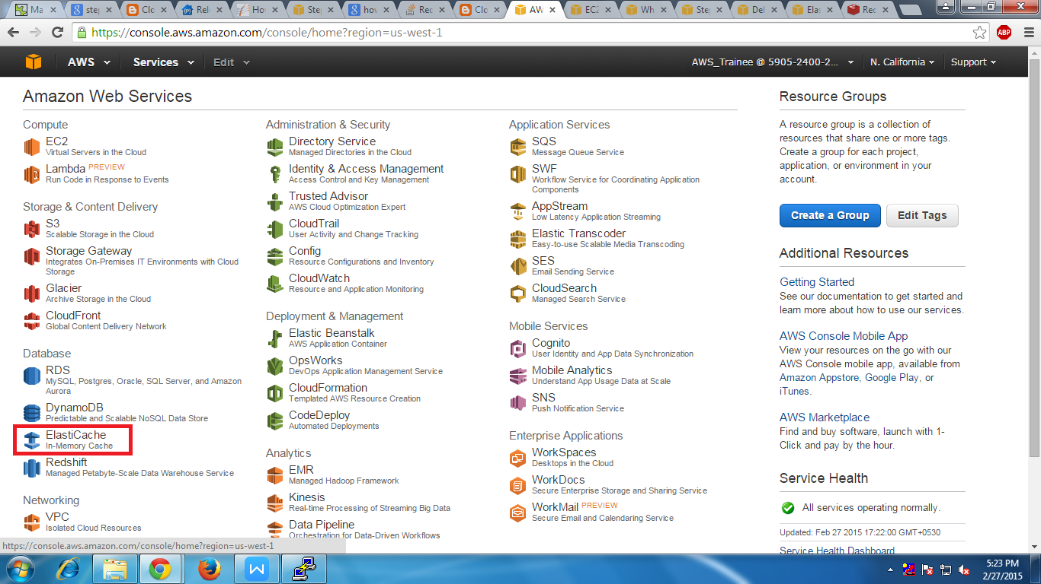

2. Than you will find a page where we have to click on launch cache cluster.

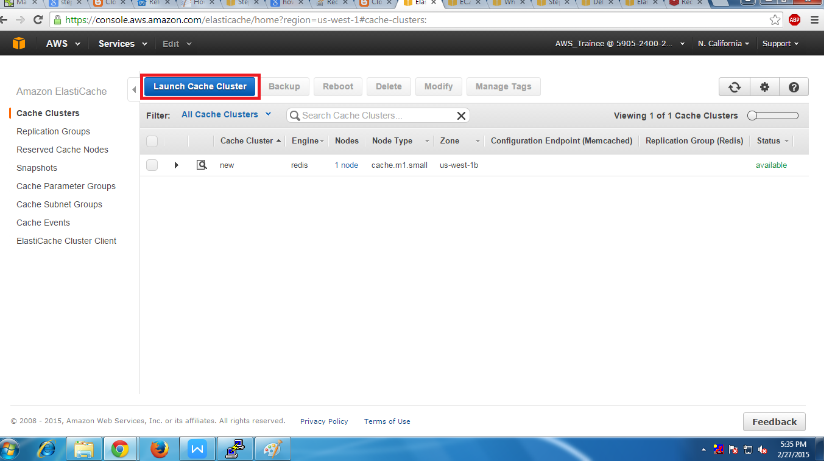

3. Than we have to select the type of cache that we want to use.

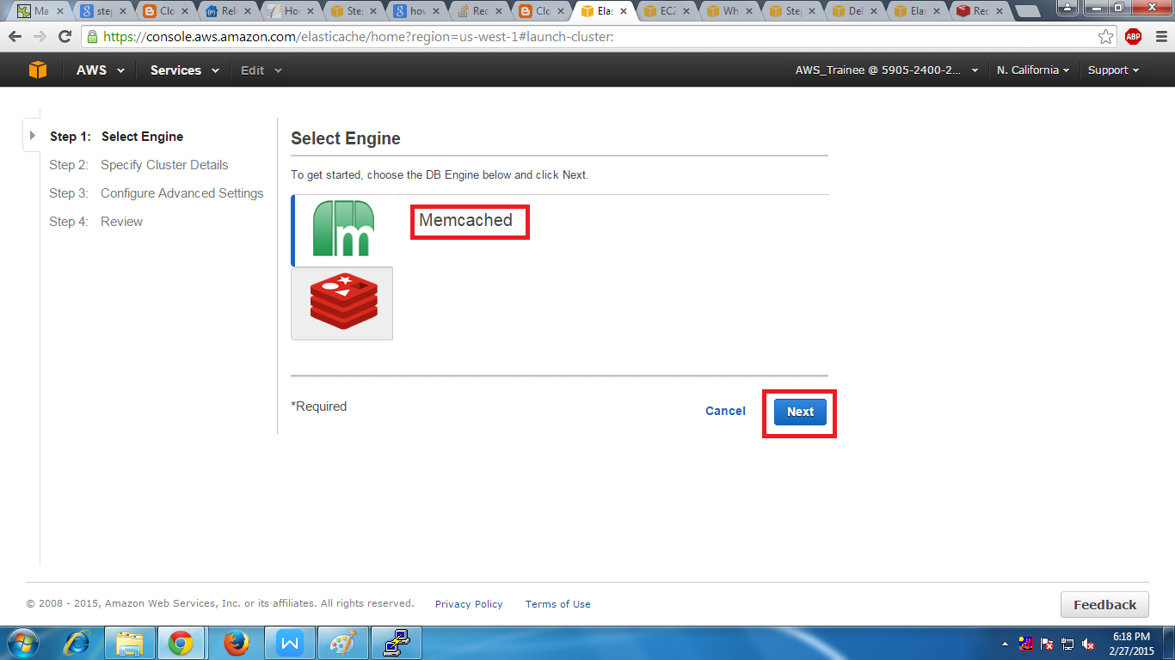

4. In next page we have to fill the configuration blanks like cluster name ,type of node and number of nodes

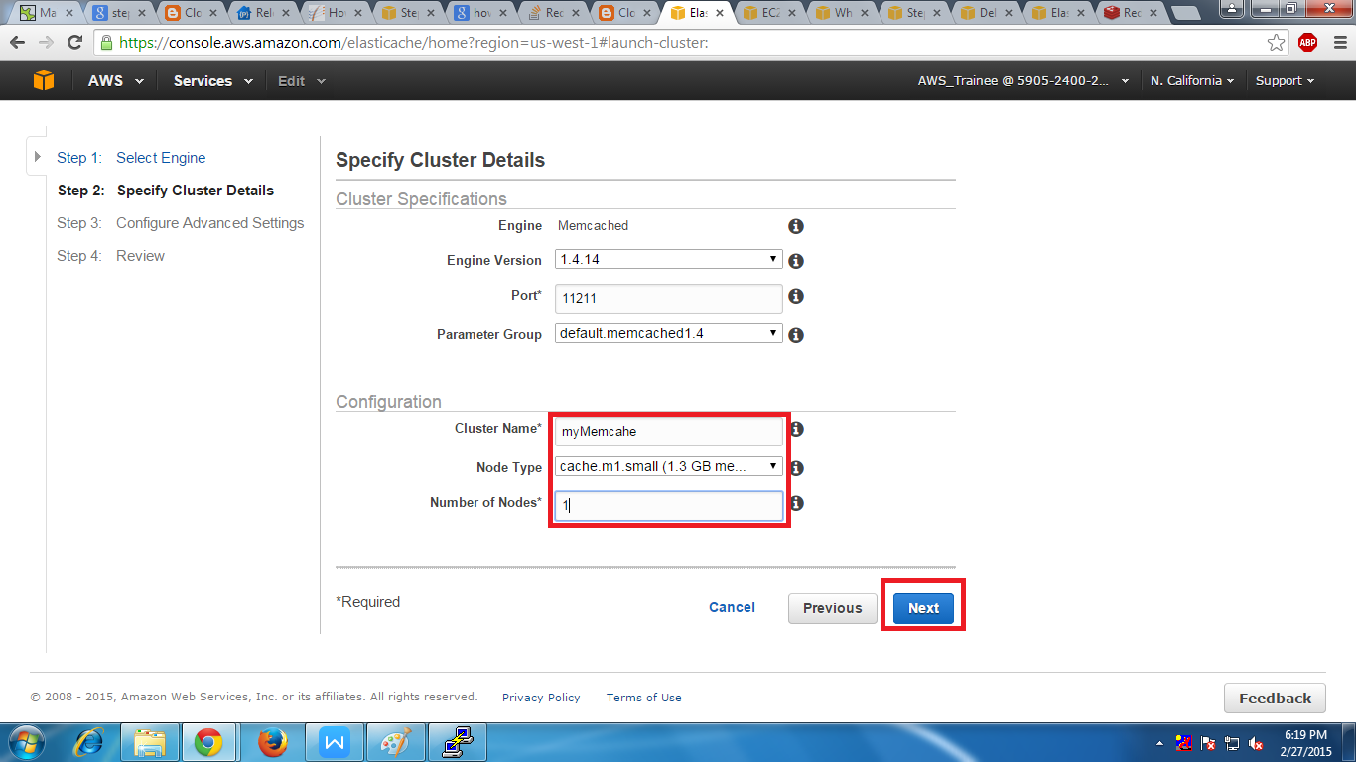

5. Inthe next page we have assign the security group and press next

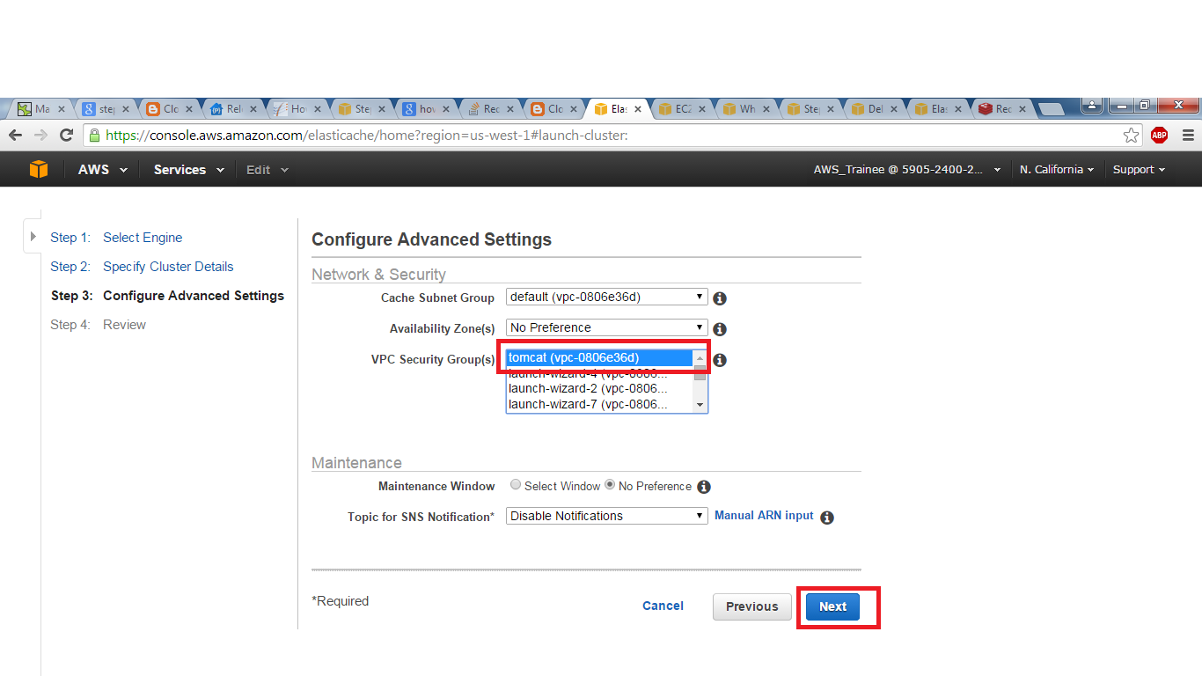

6. In the next page we will find the review of the settings aftr that we have to click launch cache cluster.

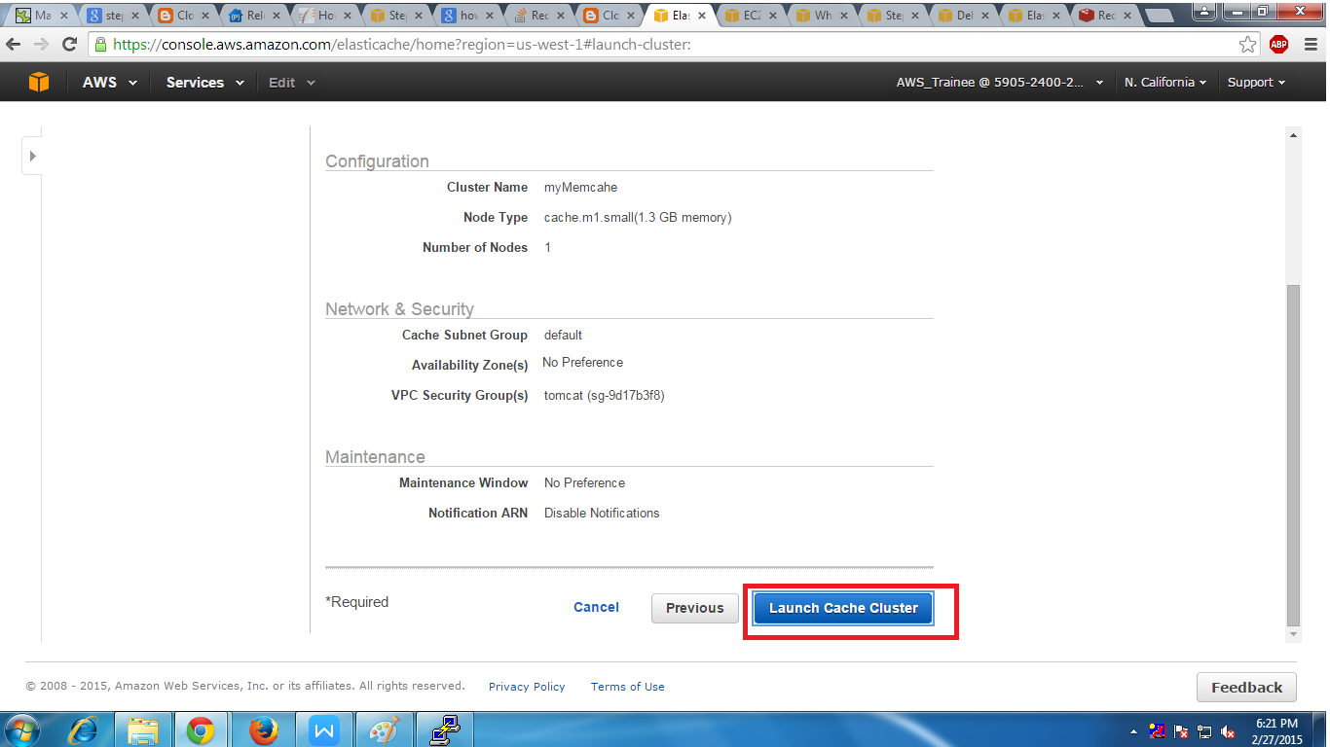

7. Than you will see a pge where we can see a message that our cluster being created

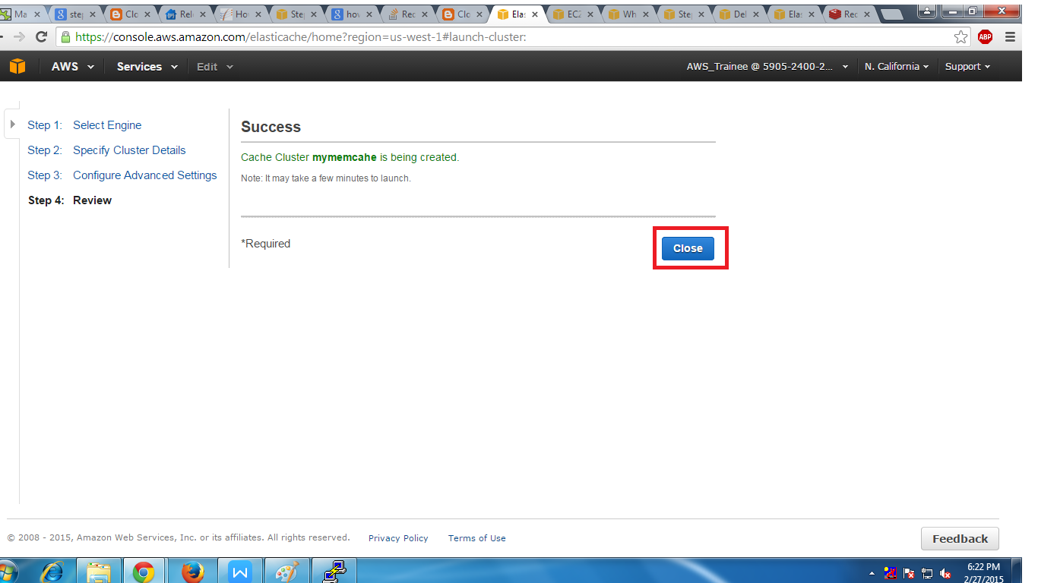

Connect to a Memcache Cluster

1. For connecting mem cache we have to use end point of the node by using the command that we will see it below.

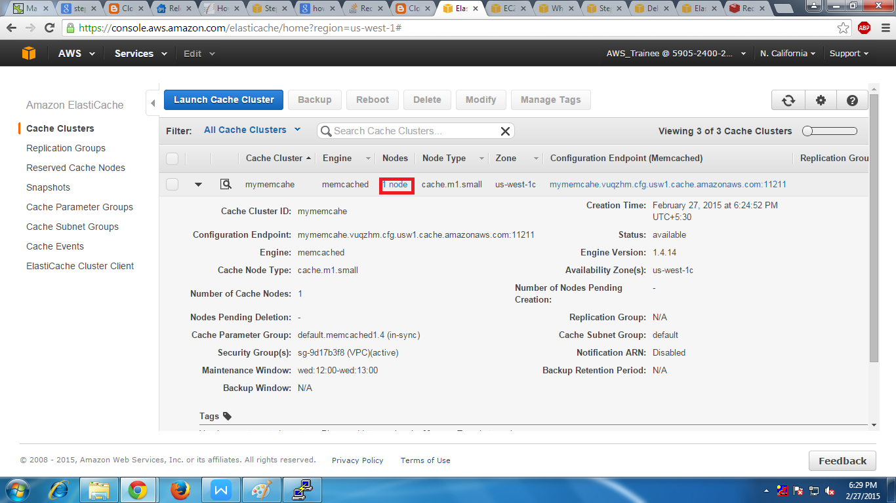

[ec2-user@ip-172-31-5-138]$ sudo yum install telnet

Loaded plugins: priorities, update-motd, upgrade-helper

Resolving Dependencies

--> Running transaction check

---> Package telnet.x86_64 1:0.17-48.8.amzn1 will be installed

--> Finished Dependency Resolution

Dependencies Resolved

========================================================================================================================================================================

Package Arch Version Repository Size

===============================================================Installing:

telnet x86_64 1:0.17-48.8.amzn1 amzn-main 62 k

Transaction Summary

===============================================================Iinstall 1 Package

Total download size: 62 k

Installed size: 107 k

Is this ok [y/d/N]: y

Downloading packages:

telnet-0.17-48.8.amzn1.x86_64.rpm | 62 kB 00:00

Running transaction check

Running transaction test

Transaction test succeeded

Running transaction

Installing : 1:telnet-0.17-48.8.amzn1.x86_64 1/1

Verifying : 1:telnet-0.17-48.8.amzn1.x86_64 1/1

Installed:

telnet.x86_64 1:0.17-48.8.amzn1

Complete!

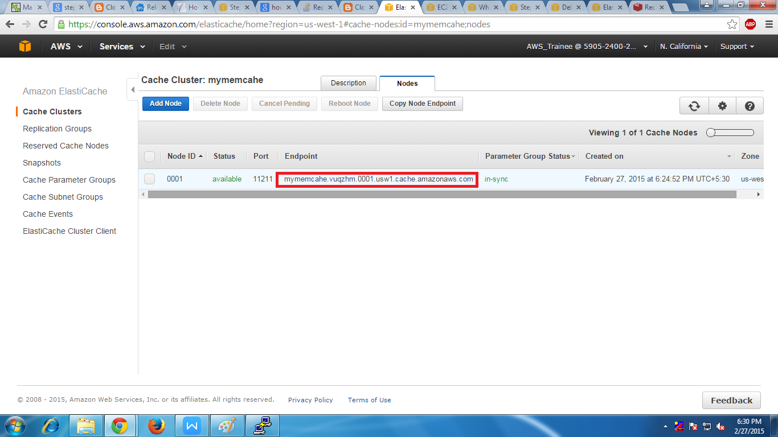

[ec2-user@ip-172-31-5-138 ~]$ telnet mymemcahe.vuqzhm.0001.usw1.cache.amazonaws.com 11211

Trying 172.31.17.199...

Connected to mymemcahe.vuqzhm.0001.usw1.cache.amazonaws.com.

Escape character is '^]'.

set s 10

get a

END